W2 assignment

Bianka Sz.

2/14/2021

## Exercise 1

Goals

* Modify the provided code to improve the resulting map

We highlighted all parts of the R script in which you are supposed to add your own code with:

/Start Code/ #

print(“Hello World”) # This would be your code contribution

/End Code/ #

Required R libraries:

We will use the sf, raster, and tmap packages. Additionally, we will use the spData and spDataLarge packages that provide new datasets. These packages have been preloaded to the worker2 workspace.

library(sf)

## Linking to GEOS 3.8.0, GDAL 3.0.4, PROJ 6.3.1

library(raster)

## Loading required package: sp

library(tmap)  
library(spData)  
library(spDataLarge)

Data sets

We will use two data sets: nz_elev and nz. They are contained by the libraries The first one is an elevation raster object for the New Zealand area, and the second one is an sf object with polygons representing the 16 regions of New Zealand.

Existing code

We wrote the code to create a new map of New Zealand. Your role is to improve this map based on the suggestions below.

#### Exercise I

1. Change the map title from “My map” to “New Zealand”.
2. Update the map credits with your own name and today’s date.
3. Change the color palette to “-RdYlGn”. (You can also try other palettes from <http://colorbrewer2.org/>)
4. Put the north arrow in the top right corner of the map.
5. Improve the legend title by adding the used units (m asl).
6. Increase the number of breaks in the scale bar.
7. Change the borders’ color of the New Zealand’s regions to black. Decrease the line width.
8. Change the background color to any color of your choice.

#Original code  
tm_shape(nz_elev) +  
 tm_raster(title = "elev",   
 style = "cont",  
 palette = "BuGn") +  
 tm_shape(nz) +  
 tm_borders(col = "red",   
 lwd = 3) +  
 tm_scale_bar(breaks = c(0, 100, 200),  
 text.size = 1) +  
 tm_compass(position = c("LEFT", "center"),  
 type = "rose",   
 size = 2) +  
 tm_credits(text = "A. Sobotkova, 2020") +  
 tm_layout(main.title = "My map",  
 bg.color = "orange",  
 inner.margins = c(0, 0, 0, 0))

## stars object downsampled to 877 by 1140 cells. See tm_shape manual (argument raster.downsample)

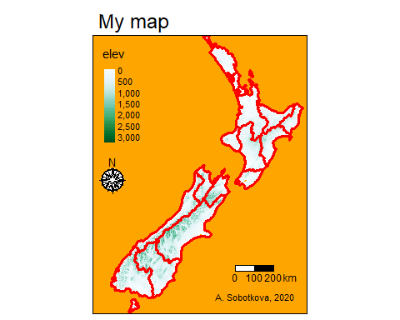

#Modified code  
tm_shape(nz_elev) +  
 tm_raster(title = "m asl", #renaming legend title  
 style = "cont",  
 palette = "-RdYlGn") + #changing color palette  
 tm_shape(nz) +  
 tm_borders(col = "black", #changing border color  
 lwd = 1) + #decreasing line width  
 tm_scale_bar(breaks = c(0, 100, 200, 300), #increasing number of breaks on scale bar  
 text.size = 1) +  
 tm_compass(position = c("RIGHT", "top"), #replacing the north arrow  
 type = "rose",   
 size = 2) +  
 tm_credits(text = "Bianka Szollosi, 14/02/2021") + #changing credits  
 tm_layout(main.title = "New Zealand", #changing title  
 bg.color = "yellow", #changing background  
 inner.margins = c(0, 0, 0, 0))

## stars object downsampled to 877 by 1140 cells. See tm_shape manual (argument raster.downsample)

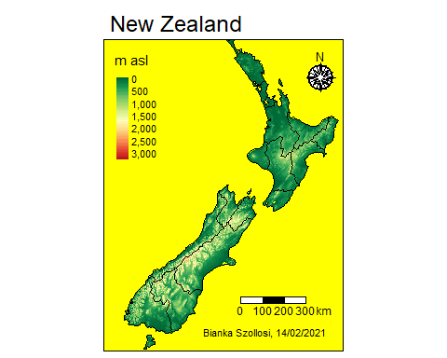 #### Exercise II ####

1. Read two new datasets, srtm and zion, using the code below. To create a new map representing these datasets.

srtm = raster(system.file("raster/srtm.tif", package = "spDataLarge"))  
zion = read_sf(system.file("vector/zion.gpkg", package = "spDataLarge"))  
  
print(srtm)

## class : RasterLayer   
## dimensions : 457, 465, 212505 (nrow, ncol, ncell)  
## resolution : 0.0008333333, 0.0008333333 (x, y)  
## extent : -113.2396, -112.8521, 37.13208, 37.51292 (xmin, xmax, ymin, ymax)  
## crs : +proj=longlat +datum=WGS84 +no_defs   
## source : C:/Users/biasz/Documents/R/win-library/4.0/spDataLarge/raster/srtm.tif   
## names : srtm   
## values : 1024, 2892 (min, max)

#New map 'srtm'  
tm_shape(srtm) +  
 tm_raster(title = "m asl", #renaming legend title  
 style = "cont",  
 palette = "-RdYlGn") + #changing color palette  
 tm_shape(zion) +  
 tm_borders(col = "black", #changing border color  
 lwd = 1) + #decreasing line width  
 tm_scale_bar(breaks = c(0, 2, 4, 6), #increasing number of breaks on scale bar  
 text.size = 1) +  
 tm_compass(position = c("RIGHT", "top"), #replacing the north arrow  
 type = "rose",   
 size = 2) +  
 tm_credits(text = "Bianka Szollosi, 14/02/2021") + #changing credits  
 tm_layout(main.title = "Zion National Park", #changing title  
 inner.margins = c(0, 0, 0, 0))

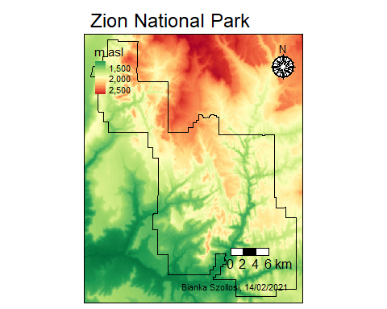 ## Exercise 2

#### Exercise I

1. Display the zion object and view its structure. -What can you say about the content of this file? Simple feature collection with 1 feature and 11 fields and it consists of 1 row and 12 columns

-What type of data does it store? the name of the unit, when it was edited, where it can be found, its type, who it was created by, metadata and the geometry

-What is the coordinate system used? UTM Zone 12

-How many attributes does it contain? 12 (number of cols)

-What is its geometry? Polygon

#will need these later  
study_area <- read_sf("data/study_area.gpkg")  
lc_data <- raster("data/example_landscape.tif")

## Warning in showSRID(uprojargs, format = "PROJ", multiline = "NO", prefer_proj  
## = prefer_proj): Discarded datum Unknown based on GRS80 ellipsoid in Proj4  
## definition

lc_data_masked <- mask(crop(lc_data, study_area), study_area)

## Warning in showSRID(uprojargs, format = "PROJ", multiline = "NO", prefer_proj  
## = prefer_proj): Discarded datum Unknown based on GRS80 ellipsoid in Proj4  
## definition

## Warning in showSRID(SRS_string, format = "PROJ", multiline = "NO", prefer_proj =  
## prefer_proj): Discarded datum unknown in Proj4 definition

print(zion)

## Simple feature collection with 1 feature and 11 fields  
## geometry type: POLYGON  
## dimension: XY  
## bbox: xmin: 302903.1 ymin: 4112244 xmax: 334735.5 ymax: 4153087  
## projected CRS: UTM Zone 12, Northern Hemisphere  
## # A tibble: 1 x 12  
## UNIT_CODE GIS_Notes UNIT_NAME DATE_EDIT STATE REGION GNIS_ID UNIT_TYPE  
## <chr> <chr> <chr> <date> <chr> <chr> <chr> <chr>   
## 1 ZION Lands - ~ Zion Nat~ 2017-06-22 UT IM 1455157 National~  
## # ... with 4 more variables: CREATED_BY <chr>, METADATA <chr>, PARKNAME <chr>,  
## # geom <POLYGON [m]>

#View(zion)

1. Display the srtm object and view its structure. -What can you say about the content of this file? it’s a raster layer with dimensions: rows: 457, columns: 465, cells: 212505

-What type of data does it store? file, data, legend, extent, rotation, crs

-What is the coordinate system used? WGS84

-How many attributes does it contain? 6 different lists (?)

-How many dimensions does it have? 3 (nrow, ncol, ncell)

-What is the data resolution? x= 0.0008333333, y= 0.0008333333

print(srtm)

## class : RasterLayer   
## dimensions : 457, 465, 212505 (nrow, ncol, ncell)  
## resolution : 0.0008333333, 0.0008333333 (x, y)  
## extent : -113.2396, -112.8521, 37.13208, 37.51292 (xmin, xmax, ymin, ymax)  
## crs : +proj=longlat +datum=WGS84 +no_defs   
## source : C:/Users/biasz/Documents/R/win-library/4.0/spDataLarge/raster/srtm.tif   
## names : srtm   
## values : 1024, 2892 (min, max)

#View(srtm)

#### Exercise II

1. Reproject the srtm dataset into the coordinate reference system used in the zion object.

* Create a new object srtm2
* Vizualize the results using the plot() function.

# Get the CRS from the canopy object  
crs1 <- crs(zion, asText = TRUE)  
  
# # Project srtm to match the CRS of zion  
srtm2 <- projectRaster(srtm, crs = crs1)

## Warning in showSRID(uprojargs, format = "PROJ", multiline = "NO", prefer_proj  
## = prefer_proj): Discarded datum Unknown based on GRS80 ellipsoid in Proj4  
## definition

#plotting result  
plot(srtm2)

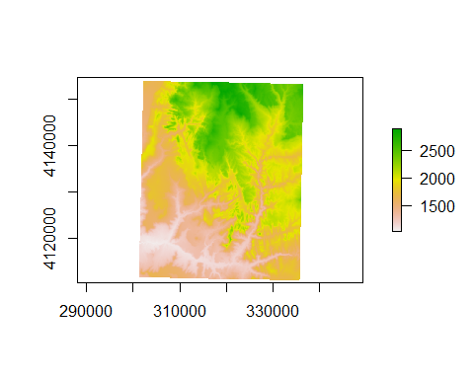

1. Reproject the zion dataset into the coordinate reference system used in the srtm object.

* Create a new object zion2
* Vizualize the results using the plot() function.

# Get the CRS from the canopy object  
crs2 <- crs(srtm, asText = TRUE)  
  
# # Project zion to match the CRS of srtm  
zion2 <- st_transform(zion, crs = crs2)  
  
#plotting result  
plot(zion2)

## Warning: plotting the first 9 out of 11 attributes; use max.plot = 11 to plot  
## all

